The states are sorted in ascending order to find the highest consumption state and the usage of it.e

Case Study Report



**Tech Saksham**

Data Analytics with Power BI

**“Analysis of Commercial Electricity Consumption in Indian States”**

**“AMBAI ARTS COLLEGE”**

|  |  |
| --- | --- |
| **NM ID** | **NAME** |
| 27CE9D4494FB35D9AAC4216FF2B92823 | NandhiniDevi.G |

|  |  |
| --- | --- |
|  |  |
| Trainer Name: R. Uma Maheswari.  Master Name: R.Uma Maheswari. |  |
|  |  |

**ABSTRACT**

This study examines the patterns and determinants of commercial electricity consumption across Indian states. Utilizing data from various sources including government reports, surveys and statistical databases, the analysis employs econometric techniques to identify factors influencing commercial electricity usage. Key variables such as economic growth, industrialization, population density, urbanization, and energy policies are considered in the analysis. The findings contribute to a better understanding of the dynamic of commercial electricity consumption in India, which is essential for policy makers, energy planners, and businesses to develop effective strategies for energy management and sustainable development.

**Keywords:** Consumption, Analytics, Electricity, Visualizations

human development. Generally, it has defined as “Capacity to do work” thereby, for bring out desirable design

**INDEX**

|  |  |  |
| --- | --- | --- |
| **Sr. No.** | **Table of Contents** | **Page No.** |
| 1 | Chapter 1: Introduction | 4 |
| 2 | Chapter 2: Services and Tools Required | 6 |
| 3 | Chapter 3: Project Architecture | 8 |
| 4 | Chapter 4: Modeling and Result | 10 |
| 5 | Conclusion | 16 |
| 6 | Future Scope | 17 |
| 7 | References | 18 |
| 8 | Links | 19 |

**CHAPTER 1**

**INTRODUCTION**

**1.1 Problem Statement**

Currently, electricity is used in every home for various tasks, including watching television, charging smartphones, using an electric light bulb, and other things. Electricity has become an essential part of our daily life. It powers our homes, businesses, and industries, and has enabled us to achieve unprecedented levels of comfort, convenience, and productivity. However, this growing dependence on electricity has led to a significant increase in its consumption, placing enormous pressure on energy resources and the environment. As a result, it has become imperative to analyze and control the supply and demand of electricity, to ensure its sustainable use and reduce the impact of its production on the environment. In recent years, there has been a noticeable rise in electricity consumption, driven by the increasing use of electronic devices, appliances, and industrial machinery. This trend is expected to continue in the coming years, with the growth of emerging markets and the adoption of new technologies, such as electric vehicles and renewable energy systems. To meet the growing electricity demand, utility companies are exploring new ways to optimize energy production and distribution, while minimizing waste and reducing emissions.

**1.2 Proposed Solution**

1. the Energy is how prominent to physical, same like significant for the economic development or any nation’s **Proposed Solution**

To achieve this goal, big data analytics has emerged as a promising tool for analyzing electricity consumption patterns and identifying opportunities for energy savings. By analyzing large volumes of data generated by smart meters and other monitoring devices, utility companies can gain insights into the behavior of individual consumers, as well as the overall trends in consumption. This information can be used to develop targeted strategies for reducing energy use, promoting energy efficiency, and managing peak demand. The paper aims to present a study on the electricity consumption patterns of 500 residential consumers in a particular area over 24 months, using big data analytics.

* 1. **Feature**
* **Gross Domestic Product (GDP):** GDP serves as a proxy for economic activity and can indicate level of commercial and industrial development within a state.
* **Energy Tariffs:** Electricity tariffs set by regulatory authorities influence commercial electricity consumption.
* **Urbanization Rate:**  The degree of urbanization reflect the proportion of the population residing in urban areas, where commercial establishments demand is higher compared to rural areas.
* **Industrial Output:** The output of industrial sector, such as manufacturing, construction and services, contributes significantly to commercial electricity consumption, making it an important feature to consider.

**1.4 Advantages**

* **Policy Formulation:** Analysis provides insights into consumption patterns, enabling policy maker to formulate targeted energy policies**.**
* **Cost Reduction**: Identifying opportunities for energy efficiency and conservation help businesses reduce operational cost**.**
* **Risk Management**: Identifying vulnerabilities and potential disruption in electricity supply chains help in developing contingency plans.
* **Competitive Advantage**: Businesses that leverage insight from electricity consumption analysis can gain a competitive advantage by optimizing their energy usage.

**1.5 Scope**

Some studies use a top-down methodology for estimating electricity demand based on its relationship (regression equations or elasticity factors) with macroeconomic variables. However, this approach is limited with regards to addressing the transformational aspects of such relationships over a longer horizon, since electricity requirement is in effect obtained as either a second or third order effect from changes in macroeconomic factors.1 It follows that all-encompassing variables like GDP or sector value additions will fail to account for dynamism in new economic activities, service demands, technologies, policies, and institutional frameworks, that in turn play a more direct role in determining level, composition and growth of demand. Hence, the role of choice and innovation in the technology-policy space needs to be factored in order to translate changes in macroeconomic variables into service demands and finally into electricity demand.

**CHAPTER 2**

**SERVICES AND TOOLS REQUIRED**

**2.1 Services Used**

* **Data Collection and Storage Services**: Electricity consumption of Indian states is collected from various industrial sectors consuming the power and the energy production resources are also collected and stored in cloud.
* **Data Processing Services**: Services like Azure Stream Analytics or AWS Kinesis Data Analytics can be used to process the real-time data.
* **Machine Learning Services**: Azure Machine Learning or AWS Sage Maker can be used to build predictive models based on historical data.

**2.2 Tools and Software used**

**Tools**:

* **Power BI**: The main tool for this project is Power BI, which will be used to create interactive dashboards for real-time data visualization.
* **Power Query**: This is a data connection technology that enables you to discover, connect, combine, and refine data across a wide variety of sources.

**Software Requirements**:

* **Power BI Desktop**: This is a Windows application that you can use to create reports and publish them to Power BI.
* **Power BI Service**: This is an online SaaS (Software as a Service) service that you use to publish reports, create new dashboards, and share insights.
* **Power BI Mobile**: This is a mobile application that you can use to access your reports and dashboards on the go.

**CHAPTER 3**

**PROJECT ARCHITECTURE**

**3.1 Architecture**

**USER FRONTEND BACKEND**

|  |  |  |
| --- | --- | --- |
|  |  | **Html5** |

**DATABASE**

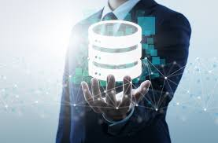

Here’s a high-level architecture for the project:

1. **Data Collection**: Gather energy consumption data from various sources, such as smart meters, sensors, or utility bills. Ensure that the data is accurate and covers a suitable timeframe for analysis.

1. **Data Storage**: The collected data is stored in a database for processing. Azure SQL Database or AWS RDS can be used for this purpose.
2. **Data Processing**: The stored data is processed in real-time using services like Azure Stream Analytics or AWS Kinesis Data Analytics.
3. **Machine Learning**: Predictive models are built based on processed data using Azure Machine Learning or AWS Sage Maker. These models can help in predicting customer behavior, detecting fraud, etc.
4. **Data Visualization**: Power BI offers a wide range of interactive visualizations, including charts, graphs, maps, tables, and custom visuals. These visualizations help in presenting data in a visually appealing and meaningful way, making it easier to understand and analyze.
5. **Data Access**: The dashboards created in Power BI can be accessed through Power BI Desktop, Power BI Service (online), and Power BI Mobile.

This architecture provides a comprehensive solution for real-time analysis of power consumption. However, it’s important to note that the specific architecture may vary depending on the electricity’s existing infrastructure, specific requirements, and budget. It’s also important to ensure that all tools and services comply with relevant data privacy and security regulations.

**CHAPTER 4**

**MODELING AND RESULT**

**Manage relationship**

The “1_data” file will be used as the main connector as it contains most key identifier (Column 1) which can be use to relates the 4 data files together. The “long_data” file is use to link the client profile geographically with “Dates”.

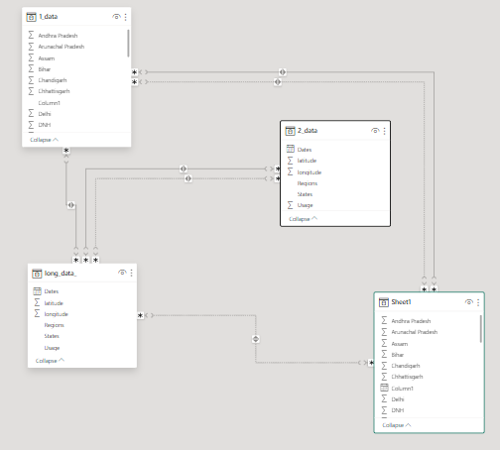

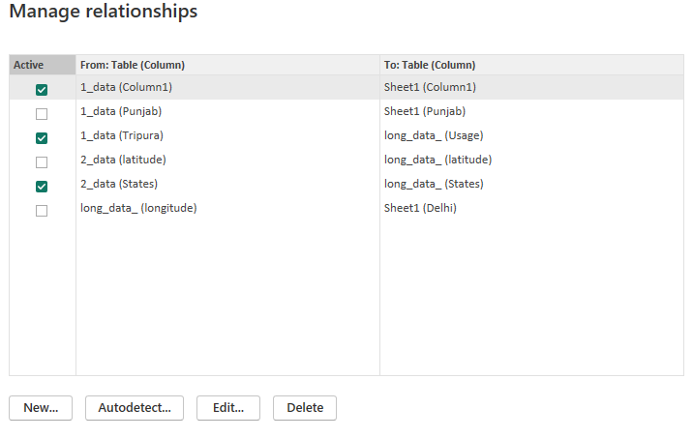

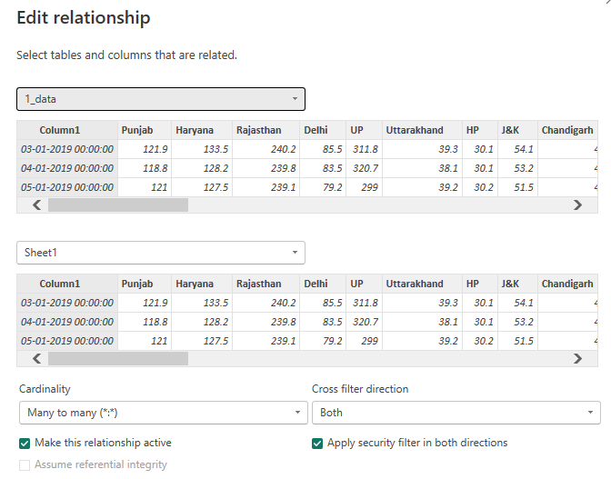

**Modeling for Date and consumption data:**

Notice that the Dates and usage of the consumption of electricity are there in the datasets by not sorted, so by using the ascending command, it is been sorted in ascending order.

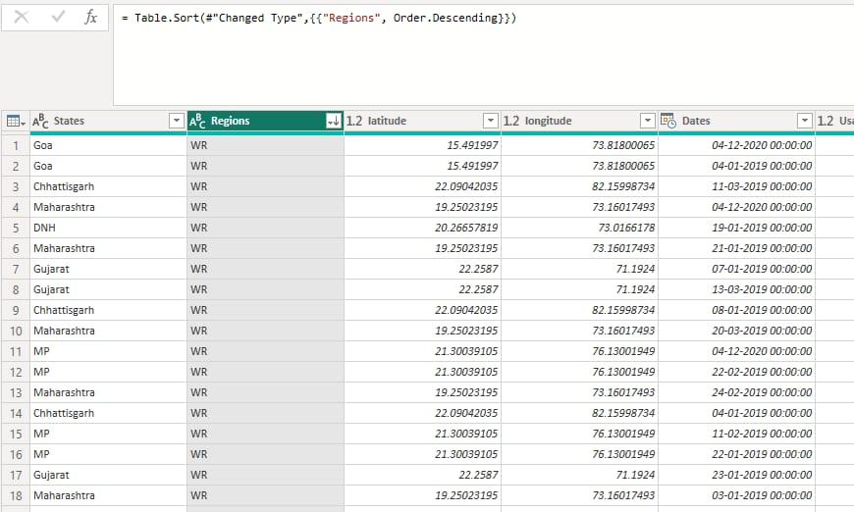

The states are sorted in ascending order to find the highest consumption state and the usage of it.

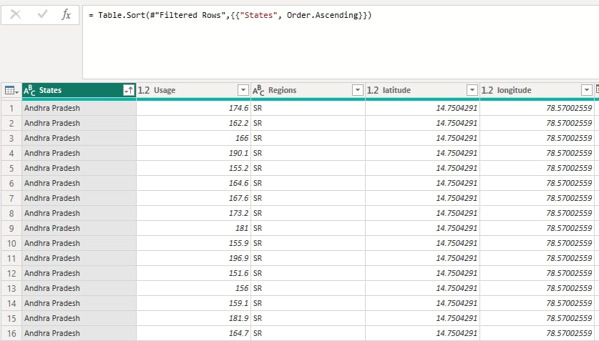

**Dashboard**

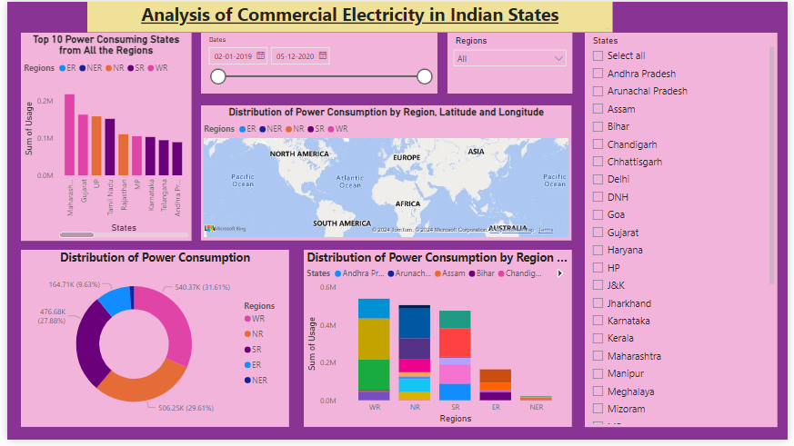

**CONCLUSION**

In conclusion, our research paper has successfully developed a consumption and prediction model that can be utilized to forecast electricity consumption for the next few months. The model, developed using the Prophet algorithm, has shown reasonable forecasting accuracy, which can be used to draw inferences about the demand-side increase and to help bolster the supply side of the equation. We have also developed a dashboard using the Power BI tool that can provide insights into the electricity consumption patterns, such as the top 10 consumers, the top 5 values and counts of months by year and users, and the average values by user. These insights can be leveraged to strategize policies and optimize energy usage in homes. Although the current model has been developed using a limited dataset, we have shown that it can perform even better with more data. Overall, our research provides a strong foundation for future studies on electricity consumption prediction and optimization.

**FUTURE SCOPE**

Future scenarios of sectoral value-added and overall and per capita GDP, are used to determine service demands in certain sectors, that in turn determine the employment of various appliances and equipment to convert electricity into end-use services(such as water pumped, steel produced, lighting and air conditioning, etc.). The government over successive years has prioritised the manufacturing sector to draw surplus labor from primary activities and enhance growth, productivity and meaningful employment. This has reflected in the National Manufacturing Policy (NMP) as well as the more recently launched Make in India (MII) campaign. Among key priorities has been increasing the share of manufacturing from 16-17 percent at present to 25 percent of GDP (Bhattacharjee, 2015). If this is achieved by 2030, then industry will need to grow at 1.5 percentage points higher than overall GDP, assuming services retains its current 60 percent share.

**REFERENCES**

https://ijarsct.co.in/Paper9099.pdf

https://wecindia.in/indias-yearly-energy-consumption-analysis/

**LINK**

<https://github.com/githubtraining/hellogitworld.git>